 |  |  | 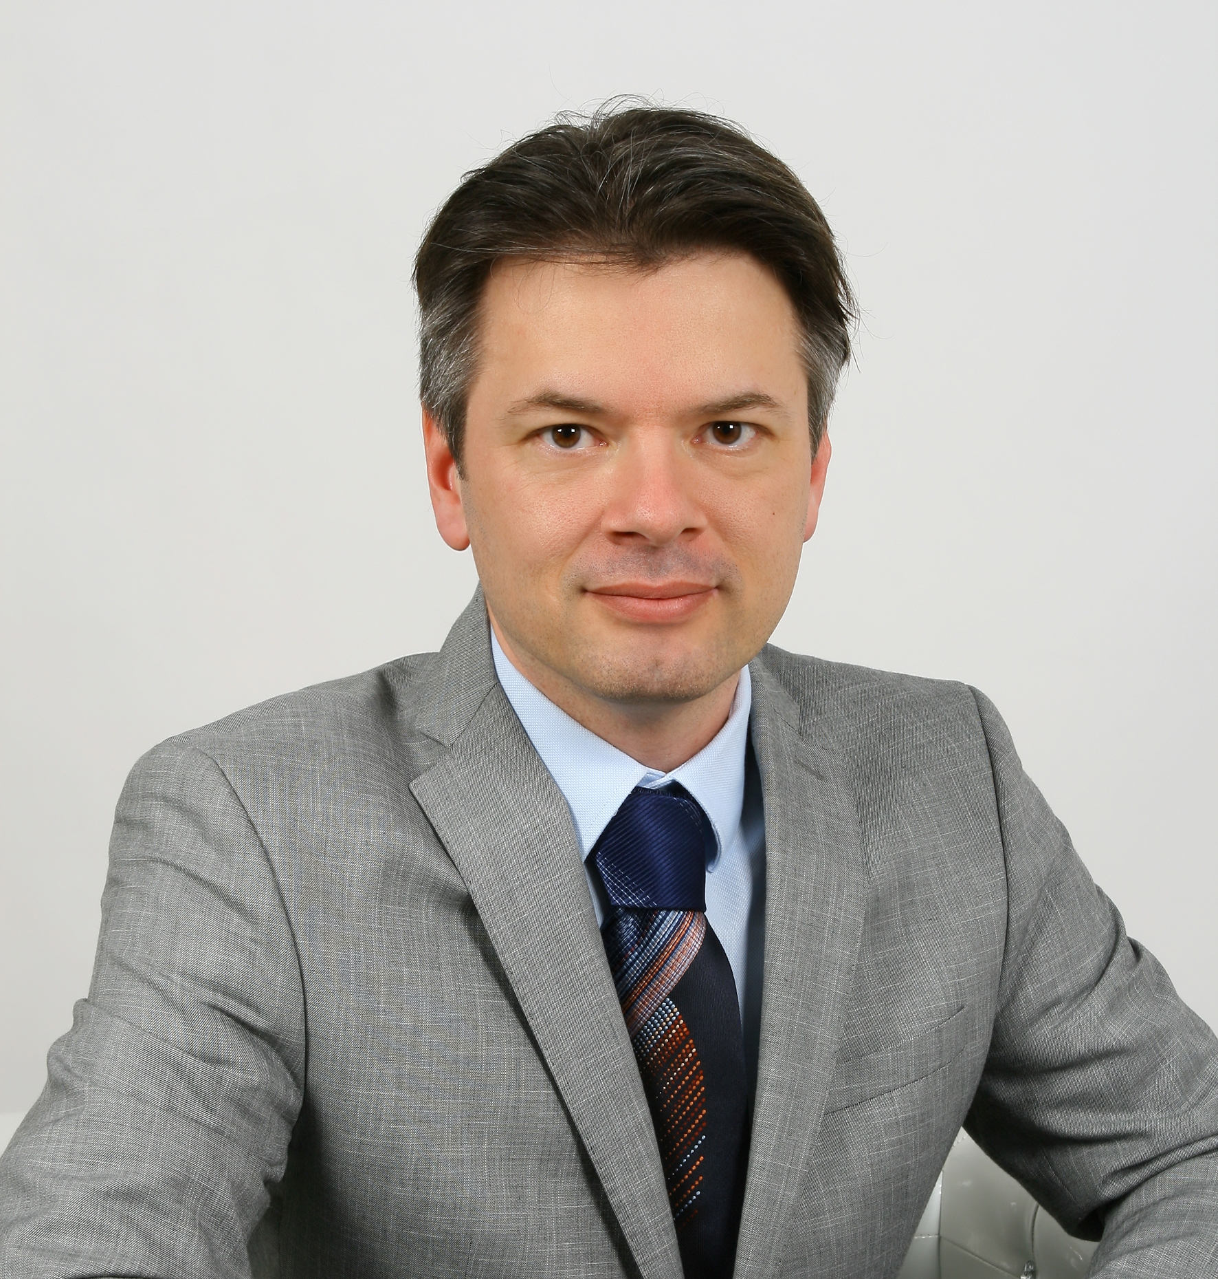
Europass CV
Personal information
Surname(s) / First name(s) |  |  | Brezovnik Boštjan
Address |  |  | Medvedova ulica 12, 2000 Maribor, Slovenia
Phone |  |  | +386 31 687 788
E-mail |  |  | bostjan.brezovnik@lex-localis.info
Nationality |  |  | Slovenian
Date of birth |  |  | 19 April 1976
Gender |  |  | male
Work experience – employment
Period |  |  | from 2001 to present
Employment or position |  |  | University teacher (associate professor)
Main duties and competences |  |  | Lecturer at undergraduate and postgraduate studies in the field of law (Public Administration, Public Administration System, Public Law, Local Self-Government).
Name and address of employer |  |  | Maria Curie-Skłodowska University in Lublin, Faculty of Law and Administration (personal web page)  pl. Marii Curie-Skłodowskiej 5, 20-031 Lublin, Poland
Type of activity or division |  |  | Tertiary education affairs, public sector
Period |  |  | 2020 to present
Employment or position |  |  | University teacher (associate professor)
Main duties and competences |  |  | Lecturer at undergraduate and postgraduate studies in the field of law (Public Administration, Public Administration System, Public Law, Local Self-Government).
Name and address of employer |  |  | New University, European Faculty of Law (personal web page)  Delpinova 18b, 5000 Nova Gorica, Slovenia
Type of activity or division |  |  | Tertiary education affairs, public sector
Period |  |  | 2020 to present
Employment or position |  |  | University teacher (associate professor)
Main duties and competences |  |  | Lecturer at undergraduate studies in the field of law (Public Administration).
Name and address of employer |  |  | University of Ljubljana, Faculty of Law  Poljanski nasip 2, 1000 Ljubljana, Slovenia
Type of activity or division |  |  | Tertiary education affairs, public sector
Period |  |  | 2019
Employment or position |  |  | University teacher (assistant/assistant professor / associate professor)
Main duties and competences |  |  | Lecturer at undergraduate and postgraduate studies in the field of law (Public Administration, Public Administration System, Public Law, Local Self-Government).
Name and address of employer |  |  | University of Maribor, Faculty of Law  Mladinska ulica 9, 2000 Maribor, Slovenia
Type of activity or division |  |  | Tertiary education affairs, public sector
Period |  |  | 2002 to 2019
Employment or position |  |  | Senior Research Associate
Main duties and competences |  |  | Cooperation in project: Adjustment of the Slovenian economy and development identity of Slovenia in the EU
Name and address of employer |  |  | University of Maribor, Faculty of Economics and Business  Razlagova 14, 2000 Maribor, Slovenia
Type of activity or division |  |  | research
Period |  |  | 2019
Employment or position |  |  | Director
Main duties and competences |  |  | Management and directing the institute
Name and address of employer |  |  | Institute for Local Self-Government Maribor  Smetanova ulica 30, 2000 Maribor, Slovenia
Type of activity or division |  |  | research
Period |  |  | 2002 …
Employment or position |  |  | Head of the University of Maribor Press
Main duties and competences |  |  | Management and directing the University of Maribor Press
Name and address of employer |  |  | University of Maribor, University of Maribor Press
Type of activity or division |  |  | management
Period |  |  | 2016 – 2017
Employment or position |  |  | Researcher and member of project groups
Main duties and competences |  |  | Cooperation in projects in the field of institute's activities
Name and address of employer |  |  | EIPF, d.o.o., Economic Institute of the Faculty of Law
Type of activity or division |  |  | Economic and financial analysis, financial, business and economic consulting.
Period: |  |  | 2017
Membership in professional councils/advisory work groups/associations/
Membership |  | National Council of the Republic of Slovenia: Group of independent experts for regionalisation of the Republic of Slovenia (head of the group) (2019 to present)
Membership |  | Council of Europe: Group of independent experts on the European Charter of local self-government (GIE) (2018 to present)
Membership |  | Government of the Republic of Slovenia/PM – Strategic Council for Regionalisation and Decentralisation (2008 – 2009)
Membership |  | Government of the Republic of Slovenia/MPA – Council for the Selection of Public officials (2008 – 2009)
Editorship
Editor-in-Chief: |  | Lex localis – Journal of local self-government  Lex localis - Journal of Local Self-Government (established in 2003) is an international journal for the study of the politics, administration and management of local affairs. Articles appearing in Lex localis abstracted and indexed in Social Sciences Citation Index (SSCI), CSA Worldwide Political Science Abstracts, Current Geographical Publications, CSA PAIS International, Academic's OneFile (Gale), ERIH Plus, International Political Science Abstracts, ProQuest, Scopus, International Bibliography of Periodical Literature (IBZ), International Bibliography of the Social Sciences (IBSS).
Editor-in-Chief: |  | Lex localis Press  Lex localis Press is an international publishing house. A collection of Lex localis Press books and conference proceedings is indexed in the Book Citation Index (Web of Science Core Collection).
Head of the Editorial Board: |  | Studia Iuridica Lublinensia  Studia Iuridica Lublienca is an international journal that publishes research results in particular in the fields of civil and commercial law, criminal law, administrative law and international law. Articles appearing in Studia Iuridica Lublinensia are indexed in BazHum; BazEkon; Index Copernicus International (ICI Journals Master List); The Central European Journal of Social Sciences and Humanities (CEJSH); Central and Eastern European Online Library (CEEOL); The European Reference Index for the Humanities and the Social Sciences (ERIH PLUS); WorldCat

Selected projects and consultations
execution of over 120 research projects and consultations, for complete list see www.cobiss.si ; http://sicris.izum.si/
 | selected fields – closer long-term cooperation and consulting activity
Institution/company/enterprise | National Council of the Republic of Slovenia
Field | Decentralisation and Regionalisation of the Republic of Slovenia
Institution/company/enterprise | OSCE Mission to Serbia
Field | Public Procurement Centralisation at Local Level
Institution/company/enterprise | UNDP Serbia
Field | Advancing Accountability Mechanisms in Public Finances
Institution/company/enterprise | KIPRED, Open Society Institute Budapest
Field | Local Self-Government Reform in Kosovo
Institution/company/enterprise | USAID, Open Society Institute Budapest
Field | Intergovernmental Finance Reform in Serbia
Institution/company/enterprise | Open Society Institute New York
Field | Assessment of the Development Program by the Croatian Law Centre.
Institution/company/enterprise | Government of the Republic of Slovenia
Field | Regionalisation and Decentralisation Models in Slovenia
Institution/company/enterprise | European Union
Field | Transformation of Public Health Institutes: Transition Facility project, No. CRIS 2006/018-158.05.01.01
Institution/company/enterprise | Government of the Republic of Slovenia (Government Office for Local Self-Government and Regional Policy)
Field | Consultancy in the field of financing local self-government and fiscal decentralization, preparation of models, technical proposals and legislation in the field of financing of municipalities and provinces, the assessment of cost structures municipalities, financing of municipalities.
Institution/company/enterprise | Housing Fund of the Republic of Slovenia
Field | Housing Policy in the Republic of Slovenia
Institution/company/enterprise | Association of Municipalities and Towns of Slovenia
Field | Competences and Tasks of the Slovenian Municipalities
Institution/company/enterprise | Slovene Chamber of Pharmacy
Field | Pharmacy Services in Slovenia
Institution/company/enterprise | Selected Slovenian municipalities/City Municipality of Maribor, Municipality of Velenje, Municipality of Lovrenc na Pohorju, Municipality of Preddvor, Municipality of Šentjur, Municipalities of the Lower Podravje region (SOU Spodnje Podravje, Municipality of Ptuj, Municipality of Kidričevo, Destrnik, Duplek, Municipality of Žetale, Municipality of Hoče-Slivnica, Municipality of Šmarje, Municipality of Jesenice, Municipality of Železniki, etc. (more than 150 Slovenian Municipalities)
Field | Consultancy in the field of local self-government and public administration management.
Institution/company/enterprise | Selected Slovenian public companies / Mariborski vodovod, d.d., Komunala Ptuj, d.d., Javne službe Ptuj d.o.o., Nigrad d.d., Snaga d.d,
Field | Consultancy and expert support in the field of activity of the company, primarily in the area of implementation of the activities of commercial public services for local communities and the management and monitoring of process of harmonisation of legislation.
Institution/company/enterprise | Pharmacies Celje, Pharmacies Maribor, Pharmacies Koper, Pharmacies Gorenjska, Parmacies Ormož, Pharmacies Dolenjska
Field | Consultancy in the field of pharmacy services delivery.
Education
Period | 2004 – 2008
Level of education | PhD in law
Principal subjects/qualifications | Law
Name and status of the institution | University of Ljubljana – Faculty of Law
Level of education | PhD, 8/2
Period | 2000 – 2003
Level of education | Master's degree in law – MSc
Principal subjects/qualifications | Tax law
Name and status of the institution | University of Maribor – Faculty of Law
Level of education | MSc, 8/1
Period | 1996 – 2000
Level of education | Bachelor of Science in Law
Principal subjects/qualifications | Law
Name and status of the institution | University of Maribor – Faculty of Law
Level of education | University programme, 7
Training & Teaching
Period | 16.1.2017 – 14.2.2017
 | Erasmus+ Staff Mobility for Training
Name and status of the institution | University of Zagreb, Faculty of Law, Trg Maršala Tita 14, 10000 Zagreb, Croatia
Period | 10.6.2016 – 10.7.2016
 | Erasmus+ Staff Mobility for Teaching
Name and status of the institution | Portucalense Univerity Infante D. Henrique, Rua Dr. Natonio Bernardino de Almeida, 541 4200-072 Porto, Portugal
Period | 18.1.2016 – 18.2.2016
 | Erasmus+ Staff Mobility for Training
Name and status of the institution | Masaryk University, Faculty of Law, Veveří 158/70, Brno, Czech Republic
Period | 16.11.2015 – 21.11.2015
 | Erasmus+ Staff Mobility for Training
Name and status of the institution | Masaryk University, Faculty of Law, Veveří 158/70, Brno, Czech Republic
Additional information
Author of over 40 scientific and professional articles published in domestic and foreign journals, author and/or co-author of more than 15 monographs (two scientific monographs are indexed in Book citation Index at Web of Science) and scientific-technical papers at conferences, co-authorship of scientific monographs, guest lecturer, participation in international projects, over 120 completed projects in the field of research and advising public and private institutions and enterprises, more than 40 mentorships diplomas at undergraduate and postgraduate studies, mentor to master and PhD students, member of the editorial boards of publications, editor in chief, media reports and participation in media events, etc. (more details can be found in the bibliographic database http://sicris.izum.si).

Selected ARRS projects – Slovenian Research Agency
Project management capabilities: completed over 120 minor and major research and consulting projects in various fields, either as project manager or participating in research groups – some of the selected projects and international relevant publications are listed above, for more information visit and http://sicris.izum.si/ : | - Research Programme (RP), P5-0027: Adjustment of the Slovenian economy and development identity of Slovenia in the EU (2018 to present)  - Research Programme (RP), P5-0287: Macroeconomic econometric analysis of development, growth and internal and external stability of the Slovenian economy (2014-2017)  - Project, J5-2198: Reforma nepravdnih postopkov (2009-2012)  - (Targeted Research Project (TRP), V5-0266: Implementation of local commercial public services and investments in local infrastructure with an emphasis on PPP (2006 – 2008))  - Project, L5-6708: Reference model for future incorporation of e-business in legal system (2004 – 2007)

Additional information – citations – indicators of scientific success according to ARRS – Slovenian Research Agency
According to the criteria and indicators for monitoring scientific performance by groups of researchers ranked among the top 10 researchers in the field of Social Sciences/Law (link). List of publications (2001 to present). Citations in WoS and Scopus (2010 – 2020)

